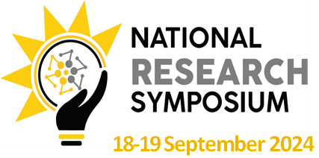

GUIDE FOR ABSTRACTS

Title
This is the title of the abstract for the National Research Symposium
(Centered Text Alignment, Book Antiqua, Font Size 14, Bold Characters)

Author(s)
Authors Names should be comprised of Initials and Surname.
E.g. Author¹, Author², and Author^{3*}
(Centered Text Alignment, Book Antiqua, Font Size 12, Bold Characters)

Authors’ Affiliated Institution’s Name
¹Department, Institution, Country if not Namibian
² Department, Institution, Country
³ Department, Institution, Country
(Centered Text Alignment, Book Antiqua, Font Size 13, Italic Characters)

Corresponding Author Contact Details
E.g., Email: name@xxxx.com; Tel/Cell: (Area Code) Number
(Left Text Alignment, Book Antiqua, Font Size 12, Regular Characters)
Body
The body of an abstract to be considered for the National Research Symposium must contain the following headers:
- Purpose,
- Method,
- Results,
- Conclusion and
- References.

Please note that the abstract must not exceed 500 words (excluding references). It may contain tables and figures.

The headers of the body of the abstract must be: Justified Text Alignment, Book Antiqua, Line Spacing 1.5, Bold Characters and Font Size 12

The body of the extended abstract must be: Justified Text Alignment, Book Antiqua, Line Spacing 1.5, Regular Characters and Font Size 12

References
Strictly use APA (American Psychological Association) referencing style

To submit your abstract:
Kindly forward an e-mail to: nrs@ncrst.na

Deadline for the Submission of Abstracts
Date: 14 June 2024
Time: 17H00

